Database Indexing and Authentication
Jeremiah (Jay) Case
SNHU
CS-340
Professor Kellogg
09/16/2026

Database Indexing and Authentication
Part I: Importing and Indexing a Data Set
The Austin Animal Center Outcomes CSV file was imported into the aac database using the animals collection. The mongoimport command used the CSV file type and the header row to establish the document fields.
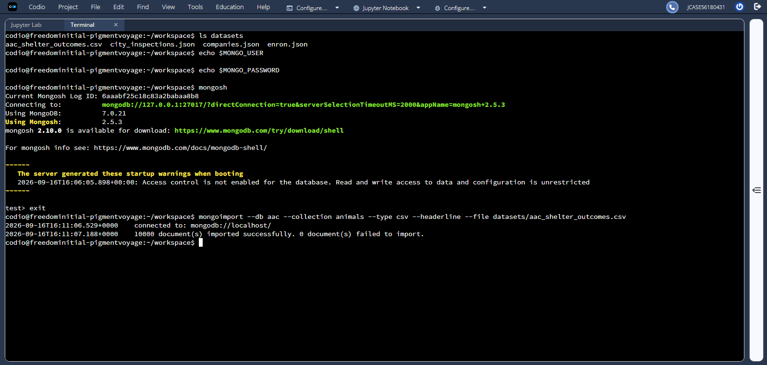
Simple Index on Breed
A simple ascending index was created on the breed field using:
db.animals.createIndex({breed: 1})
The resulting index was:
breed_1
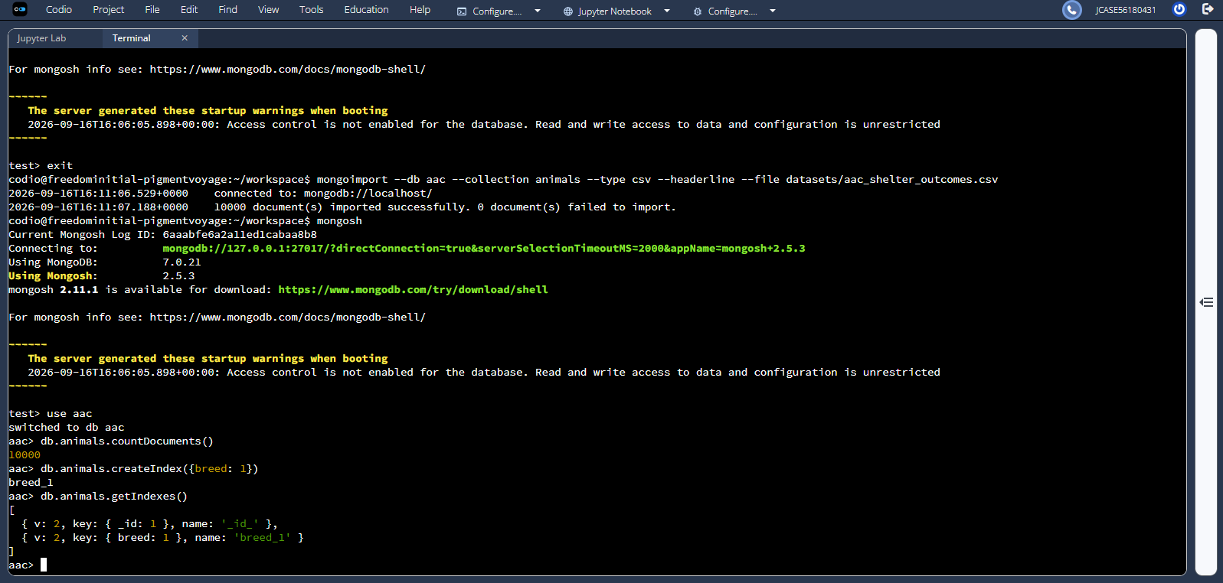
Simple Index Example Query
The following query demonstrates searching the collection by breed:
db.animals.find({breed: “Siamese Mix”}, {breed: 1, _id: 0}).limit(3)
The query successfully returned matching Siamese Mix records.
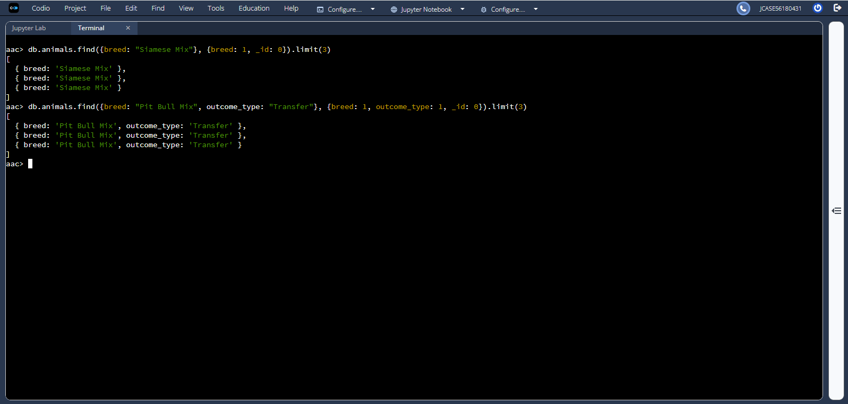
The same screenshot can also support the compound-query section below.

Verification of Simple Index
The explain(“executionStats”) function was used to verify that MongoDB used the simple index.
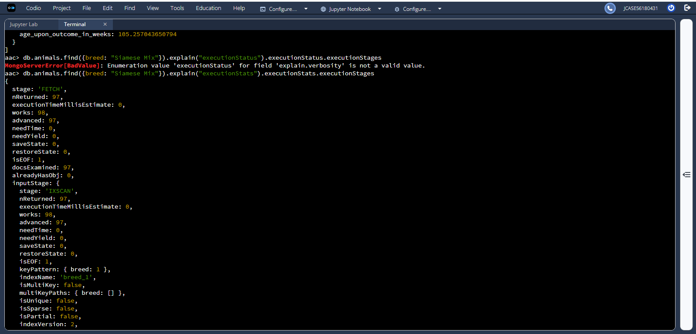
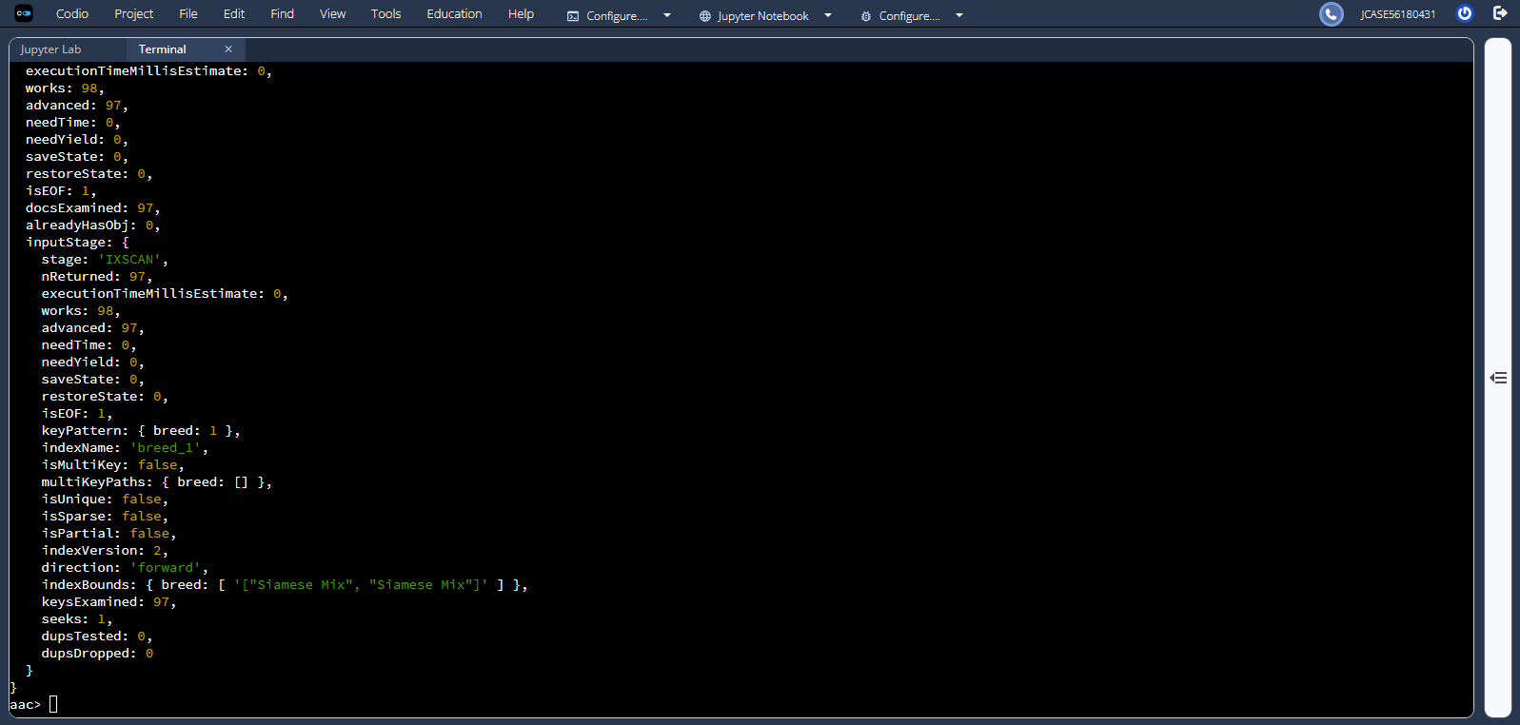
Compound Index on Breed and Outcome Type
A compound ascending index was created using the breed and outcome_type fields:
db.animals.createIndex({breed: 1, outcome_type: 1})
The resulting index was:
breed_1_outcome_type_1
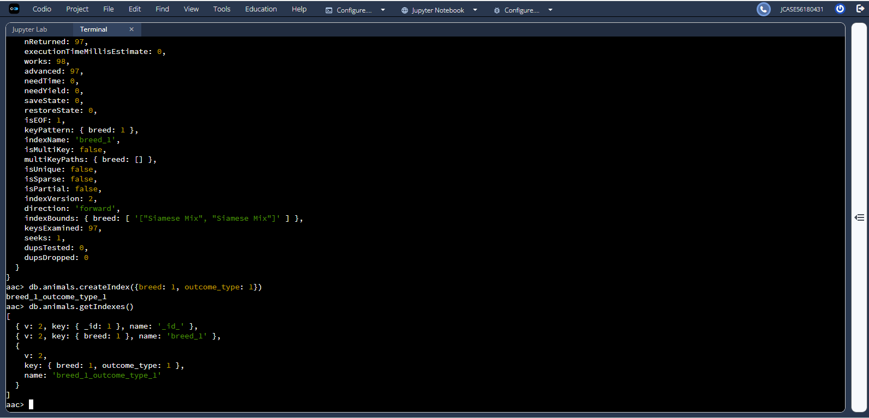
Compound Index Example Query
The compound index supports queries that search for a particular breed with an outcome_type of Transfer.
The following example was used:
db.animals.find({breed: “Pit Bull Mix”, outcome_type: “Transfer”}, {breed: 1, outcome_type: 1, _id: 0}).limit(3)
Verification of Compound Index
The explain(“executionStats”) function verified that MongoDB selected the compound index for the query.
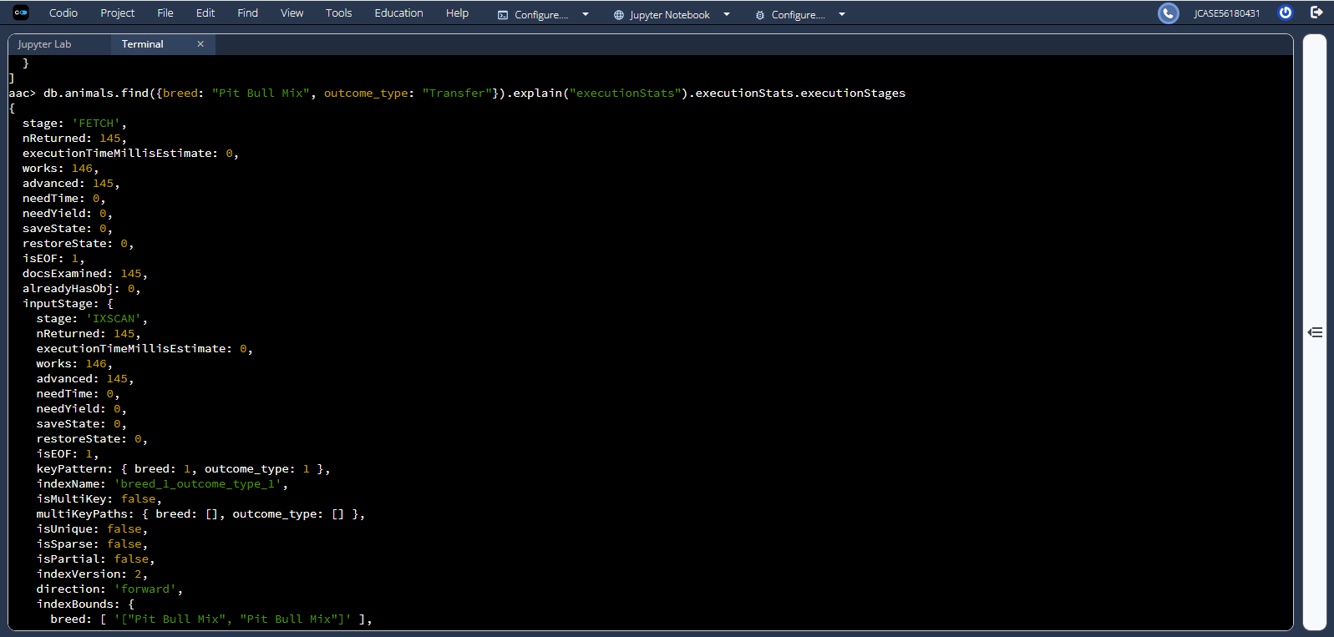
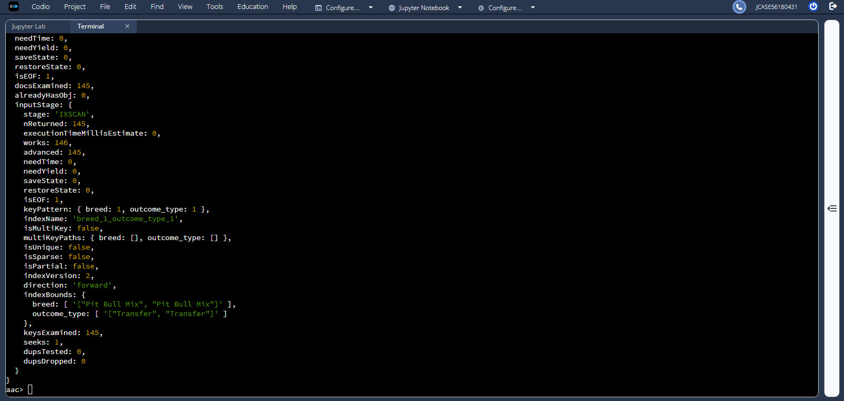
Part II: User Authentication
The aacuser account was created in the admin authentication database and assigned the readWrite role for the aac database.
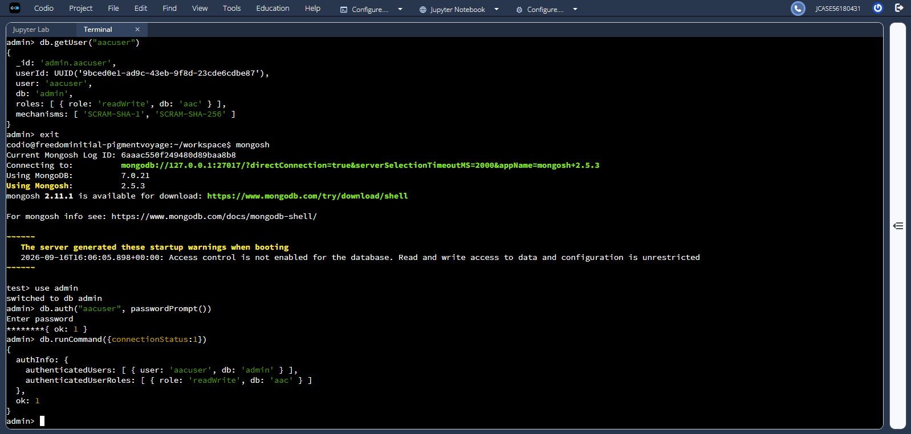

Authentication and Database Access
The aacuser account was authenticated using MongoDB’s password prompt:
db.auth(“aacuser”, passwordPrompt())
Authentication succeeded with:
{ ok: 1 }
The required command was then executed:
db.runCommand({connectionStatus:1})
